2024 MDCSS Spring Conference Keynote Speaker Biography

Drew Shuptar-Rayvis (Pekatawas MakataWai’U “Black Corn”)
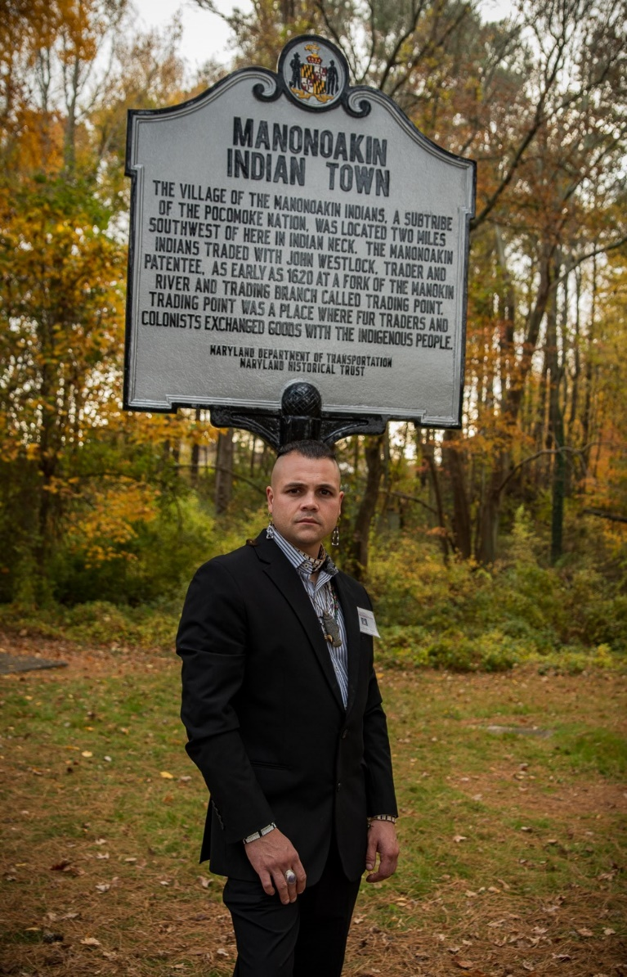
Drew Shuptar-Rayvis (Pekatawas MakataWai’U “Black Corn”) holds a cum
laude Bachelor of Arts in Anthropology and Sociology from Western Connecticut State University and a Certificate Degree in Archaeology from Norwalk Community College.
A true American of the mid-Atlantic region, his family includes indigenous Pocomoke heritage, Pennsylvania Dutch, Welsh, Swiss, English, Scots Irish, Boyko Ukrainian and Ashkenazi / Sephardic Jewish, he honors all of his ancestors as a practicing living historian and regularly participates in colonial era reenactments, interpretations and public educational events. He works diligently in the research and preservation of the Eastern Woodland languages, particularly Renape, Nanticoke and Southern Unami Dialects. He is also educated in the many European languages at use in the Colonial Period. He
was the first garden manager of Western Connecticut State University’s
Permaculture Garden, and practices Native horticulture.
In July 2021, Drew was elected by his Paramount Chief Norris Howard Senior and council member Norris Howard Junior as Cultural Ambassador of the Pocomoke Indian Nation of Maryland. Drew currently works as an Algonkian historical consultant with NAHC (New Amsterdam History Center) and for the Maryland State Archives as a contractual research and preservation specialist, working with tribal oral histories and lifeways. Lastly, he has been featured in various historical films and has modeled for historical artists Don Troiani, Michael Keropian, and David Hasseler.

